## **User Interface Design**

### Web application Design

#### **Customer Interface Design**

#### **Staff Interface Design**

##### **Staff home page**

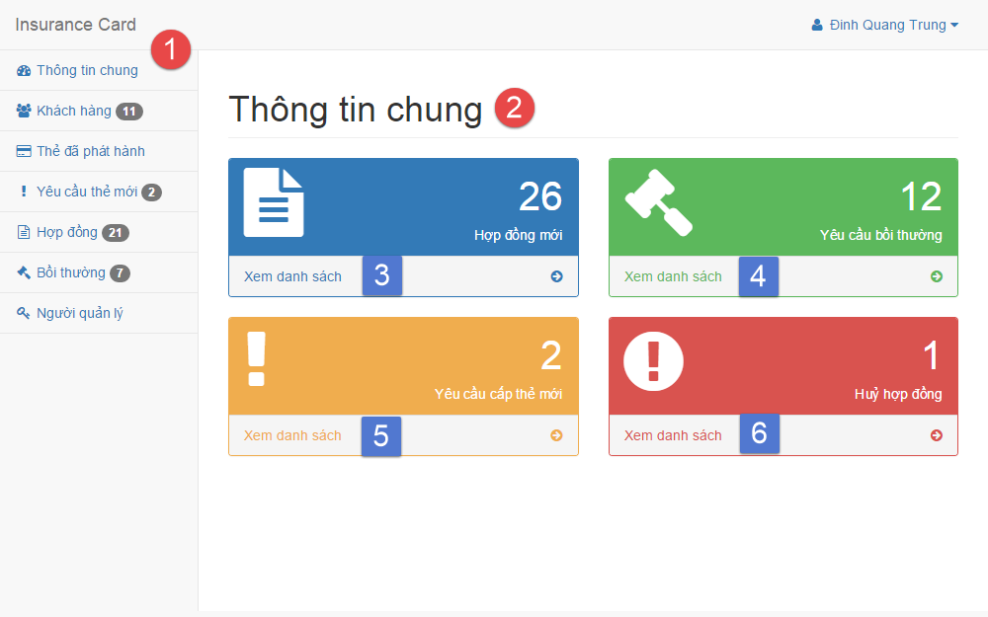

**Fields**

|  |  |  |  |  |  |  |  |
| --- | --- | --- | --- | --- | --- | --- | --- |
| **No** | **Field Name** | **Description** | **Read only** | **Mandatory** | **Control Type** | **Data Type** | **Length** |
| 1 | Menu | Navigation bar | Yes | Yes | Menu bar | N/A | N/A |
| 2 | Title | Title of the page | Yes | Yes | Label | N/A | N/A |

**Button/Hyperlinks**

|  |  |  |  |  |
| --- | --- | --- | --- | --- |
| **No** | **Function** | **Description** | **Validation** | **Outcome** |
| 3 | View | List all contract | N/A | Transfer to list contract page |
| 4 | View | List all compensation | N/A | Transfer to list compensation page |
| 5 | View | List all new card request | N/A | Transfer to list new card request page |
| 6 | View | List all cancel contract request | N/A | Transfer to list contract page |

##### **Manage customer**

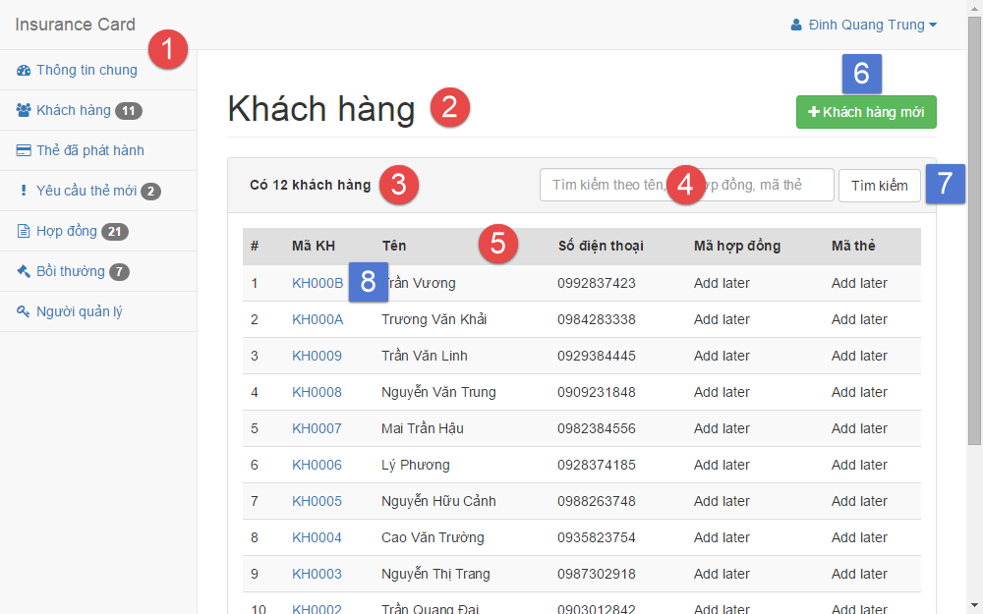

**Fields**

|  |  |  |  |  |  |  |  |
| --- | --- | --- | --- | --- | --- | --- | --- |
| **No** | **Field Name** | **Description** | **Read only** | **Mandatory** | **Control Type** | **Data Type** | **Length** |
| 1 | Menu | Navigation bar | Yes | Yes | Menu bar | N/A | N/A |
| 2 | Title | Title of the page | Yes | Yes | Label | N/A | N/A |
| 3 | Number | Number of available customer | Yes | No | Label | N/A | N/A |
| 4 | Search | Fill search keyword | No | Yes | Textbox | String | N/A |
| 5 | Table | Table of available customer | Yes | Yes | Table | N/A | N/A |

**Button/Hyperlinks**

|  |  |  |  |  |
| --- | --- | --- | --- | --- |
| **No** | **Function** | **Description** | **Validation** | **Outcome** |
| 6 | Create | Create new customer | N/A | Transfer to create new customer page |
| 7 | Search | Search by input keyword | N/A | Transfer to search result page |
| 8 | View | View customer detail | N/A | Transfer to customer detail page |

##### **Create customer**

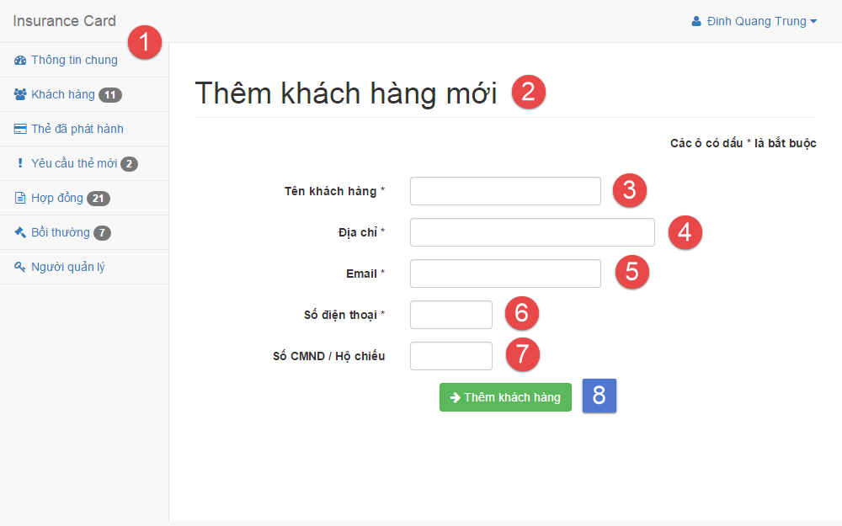

**Fields**

|  |  |  |  |  |  |  |  |
| --- | --- | --- | --- | --- | --- | --- | --- |
| **No** | **Field Name** | **Description** | **Read only** | **Mandatory** | **Control Type** | **Data Type** | **Length** |
| 1 | Menu | Navigation bar | Yes | Yes | Menu bar | N/A | N/A |
| 2 | Title | Title of the page | Yes | Yes | Label | N/A | N/A |
| 3 | Name | Fill customer name | No | Yes | Textbox | String | 3 – 80 |
| 4 | Address | Fill address | No | Yes | Textbox | String | 3 – 250 |
| 5 | Email | Fill email | No | Yes | Textbox | String | 3 – 250 |
| 6 | Phone | Fill phone | No | Yes | Textbox | Integer | 8 – 15 |
| 7 | Personal ID | Fill personal ID | No | No | Textbox | Integer | 8 – 15 |

**Button/Hyperlinks**

|  |  |  |  |  |
| --- | --- | --- | --- | --- |
| **No** | **Function** | **Description** | **Validation** | **Outcome** |
| 8 | Create | Create new customer | N/A | Transfer to create new customer successful page |

##### **Manage contract**

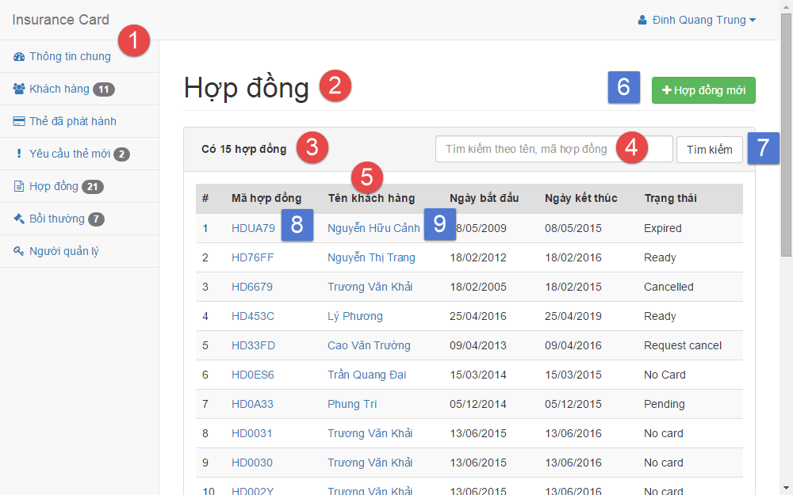

**Fields**

|  |  |  |  |  |  |  |  |
| --- | --- | --- | --- | --- | --- | --- | --- |
| **No** | **Field Name** | **Description** | **Read only** | **Mandatory** | **Control Type** | **Data Type** | **Length** |
| 1 | Menu | Navigation bar | Yes | Yes | Menu bar | N/A | N/A |
| 2 | Title | Title of the page | Yes | Yes | Label | N/A | N/A |
| 3 | Number | Number of available contract | Yes | No | Label | N/A | N/A |
| 4 | Search | Fill search keyword | No | Yes | Textbox | String | N/A |
| 5 | Table | Table of available customer | Yes | Yes | Table | N/A | N/A |

**Button/Hyperlinks**

|  |  |  |  |  |
| --- | --- | --- | --- | --- |
| **No** | **Function** | **Description** | **Validation** | **Outcome** |
| 6 | Create | Create new contract | N/A | Transfer to create new contract page |
| 7 | Search | Search by input keyword | N/A | Transfer to search result page |
| 8 | View | View contract detail | N/A | Transfer to contract detail page |
| 9 | View | View customer detail | N/A | Transfer to customer detail page |

##### **Create contract**

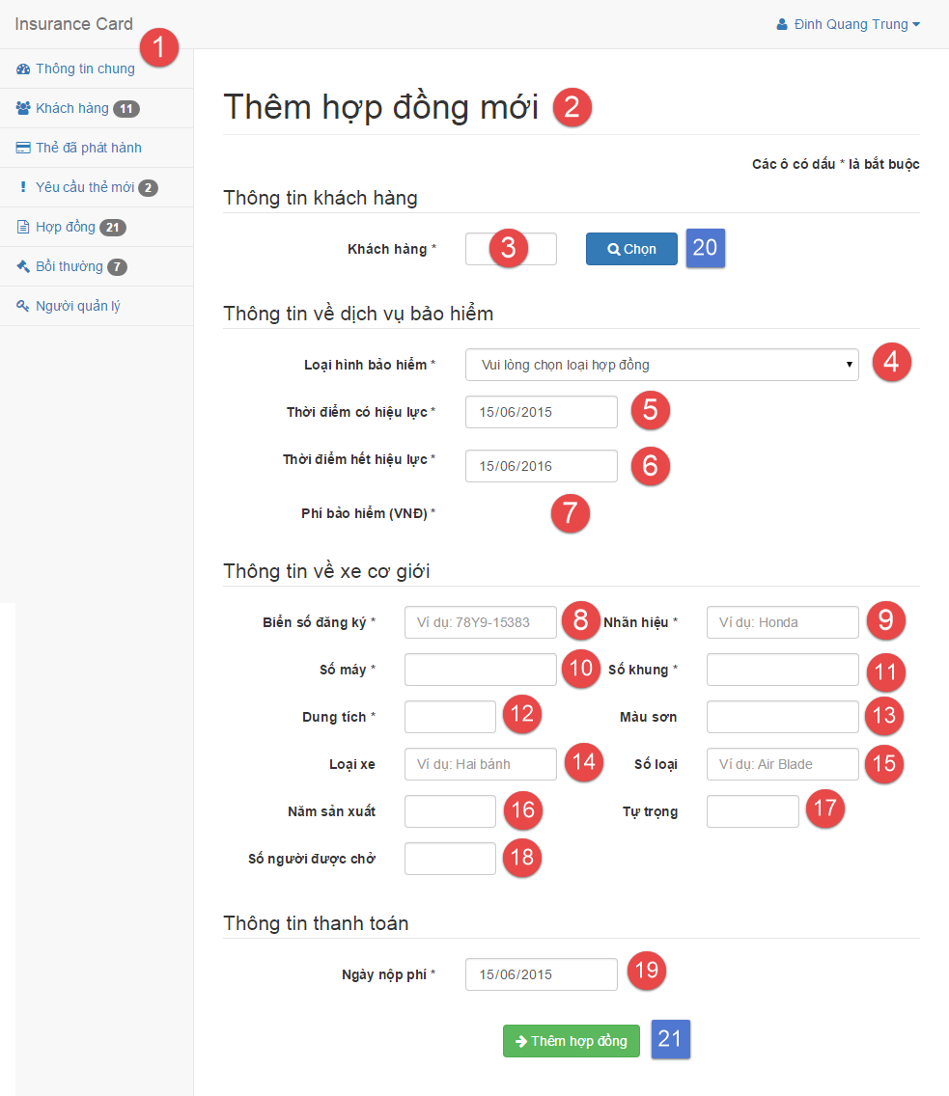

**Fields**

|  |  |  |  |  |  |  |  |
| --- | --- | --- | --- | --- | --- | --- | --- |
| **No** | **Field Name** | **Description** | **Read only** | **Mandatory** | **Control Type** | **Data Type** | **Length** |
| 1 | Menu | Navigation bar | Yes | Yes | Menu bar | N/A | N/A |
| 2 | Title | Title of the page | Yes | Yes | Label | N/A | N/A |
| 3 | Customer code | Fill customer code | No | Yes | Textbox | String | 6 |
| 4 | Contract type | Select contract type | No | Yes | Select | N/A | N/A |
| 5 | Start date | Select start date | No | Yes | Date input form | N/A | N/A |
| 6 | Expired date | Select expired date | No | Yes | Date input form | N/A | N/A |
| 7 | Contract fee | Contract fee | Yes | Yes | Label | N/A | N/A |
| 8 | Plate | Fill vehicle plate | No | Yes | Textbox | String | 4 – 15 |
| 9 | Brand | Fill vehicle brand | No | Yes | Textbox | String | 2 – 20 |
| 10 | Engine | Fill vehicle engine | No | Yes | Textbox | String | 2 – 20 |
| 11 | Chassis | Fill vehicle chassis | No | Yes | Textbox | String | 2 – 20 |
| 12 | Capacity | Fill vehicle capacity | No | Yes | Textbox | String | 2 – 20 |
| 13 | Color | Fill vehicle color | No | No | Textbox | String | 2 – 20 |
| 14 | Type | Fill vehicle type | No | No | Textbox | String | 2 – 20 |
| 15 | Model code | Fill vehicle model code | No | No | Textbox | String | 2 – 20 |
| 16 | Year of manufacture | Fill vehicle year of manufacture | No | No | Textbox | String | 4 |
| 17 | Weight | Fill vehicle empty weight | No | No | Textbox | String | 1 – 4 |
| 18 | Seat capacity | Fill vehicle seat capacity | No | No | Textbox | String | 1 – 3 |
| 19 | Paid date | Select paid contract fee date | No | Yes | Date input form | N/A | N/A |

**Button/Hyperlinks**

|  |  |  |  |  |
| --- | --- | --- | --- | --- |
| **No** | **Function** | **Description** | **Validation** | **Outcome** |
| 20 | Select | Select customer | N/A | Transfer to select customer modal |
| 21 | Create | Create new contract | N/A | Transfer to create new contract successful page |

##### **Renew contract**

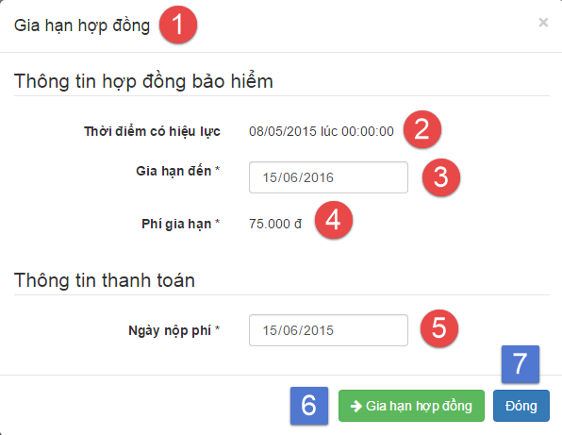

**Fields**

|  |  |  |  |  |  |  |  |
| --- | --- | --- | --- | --- | --- | --- | --- |
| **No** | **Field Name** | **Description** | **Read only** | **Mandatory** | **Control Type** | **Data Type** | **Length** |
| 1 | Title | Title of the modal | Yes | Yes | Label | N/A | N/A |
| 2 | Start date | Contract’s start date | Yes | Yes | Label | N/A | N/A |
| 3 | Expired date | Select expired date | No | Yes | Date input form | N/A | N/A |
| 4 | Renew contract fee | Renew contract fee | Yes | Yes | Label | N/A | N/A |
| 5 | Paid date | Select paid contract fee date | No | Yes | Date input form | N/A | N/A |

**Button/Hyperlinks**

|  |  |  |  |  |
| --- | --- | --- | --- | --- |
| **No** | **Function** | **Description** | **Validation** | **Outcome** |
| 6 | Renew | Renew contract | N/A | Transfer to renew contract successful page |
| 7 | Close | Close modal | N/A | Transfer to contract detail page |

##### **Cancel contract**

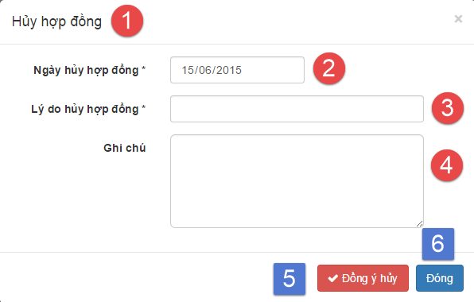

**Fields**

|  |  |  |  |  |  |  |  |
| --- | --- | --- | --- | --- | --- | --- | --- |
| **No** | **Field Name** | **Description** | **Read only** | **Mandatory** | **Control Type** | **Data Type** | **Length** |
| 1 | Title | Title of the modal | Yes | Yes | Label | N/A | N/A |
| 2 | Cancel date | Select cancel contract date | No | Yes | Date input form | N/A | N/A |
| 3 | Cancel reason | Fill cancel contract reason | No | Yes | Textbox | String | 1 – 250 |
| 4 | Cancel note | Fill note about cancel contract | No | No | Text area | String | 1 - 2000 |

**Button/Hyperlinks**

|  |  |  |  |  |
| --- | --- | --- | --- | --- |
| **No** | **Function** | **Description** | **Validation** | **Outcome** |
| 5 | Cancel contract | Cancel contract | N/A | Transfer to cancel contract successful page |
| 6 | Close | Close modal | N/A | Transfer to contract detail page |